**# Screenshot for smart map search or Data considering following variables**

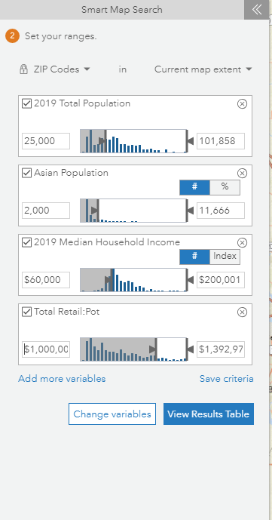

**# Screenshot of locations in DFW area found after applying above filters**

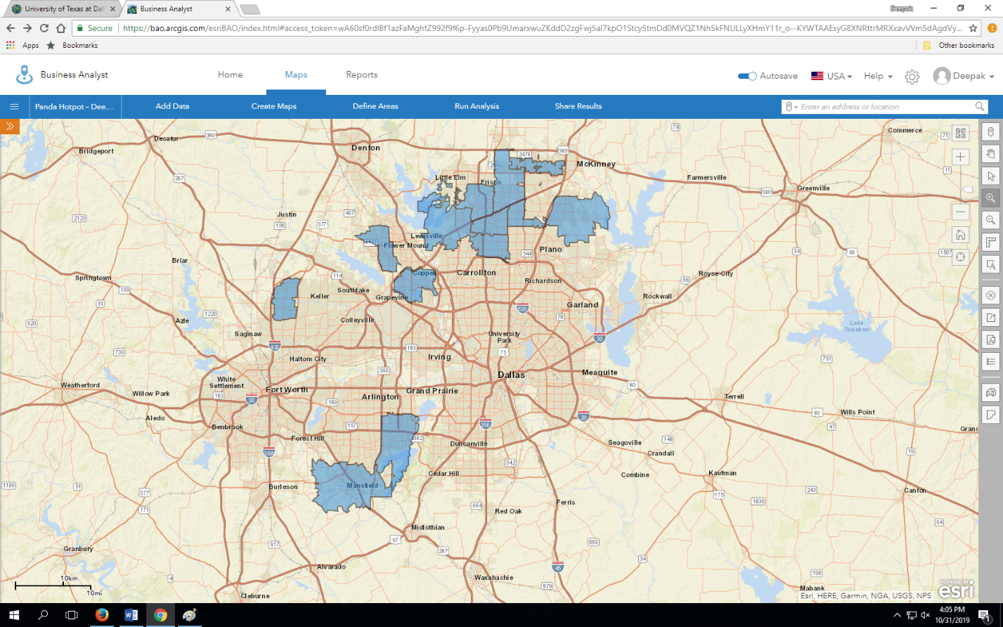

**# Customer Profiles for type of people targeted to get most business from. Tapestries are provided by ArcGIS ESRI.**

CUSTOMER PROFILE 1: *This is the new growth market, with a profile similar to the original: young professionals with families that have opted to trade up to the newest housing in the suburbs. This is an affluent market but with a higher proportion of mortgages. Residents are well-educated professionals with a running start on prosperity. --* **Boomburgs**

CUSTOMER PROFILE 2: *Residents are predominantly single, well-educated professionals in business, finance, legal, computer, and entertainment occupations. They are affluent and partial to city living—and its amenities. Neighborhoods are densely populated, primarily located in the cities of large metropolitan areas. Although single householders technically outnumber couples, this market includes a higher proportion of partner households, including the highest proportion of same-sex couples. Residents are more interested in the stock market than the housing market. They are active and health conscious, and care about the environment. --* **Laptops and Lattes**

CUSTOMER PROFILE 3: *Armed with the motto “you’re only young once,” these residents live life to its full potential. These educated young singles aren’t ready to settle down; they tend to not own homes or vehicles and choose to spend their disposable income on upscale city living and entertainment. Dressed head to toe in the most current fashions, their weeknights and weekends are filled discovering local art and culture, dining out, or exploring new hobbies. Their vacations are often spontaneous, packed with new experiences and chronicled on their Facebook pages.* -- **Trendsetters**

CUSTOMER PROFILE 4: *Residents are younger and more mobile and ethnically diverse than the previous generation. They are ambitious, working hard to get ahead, and willing to take some risks to achieve their goals. The recession has impacted their financial well-being, but they are optimistic. Their homes are new; their families are young. And this is one of the fastest-growing markets in the country.* -- **Up and coming families**

CUSTOMER PROFILE 5: *Gen Y comes of age: Well-educated young workers, some of whom are still completing their education, are employed in professional/technical occupations, as well as sales and office/administrative support roles. These residents are not established yet, but striving to get ahead and improve themselves. This market ranks in the top 5 for renters, movers, college enrollment, and labor force participation rate. Almost 1 in 5 residents move each year. More than half of all householders are under the age of 35, the majority living alone or in shared nonfamily dwellings. Median household income is still below the US Smartphones are a way of life, and they use the Internet extensively. Consumers are diverse, favoring densely populated neighborhoods in large metropolitan areas; over 50% are located in the South (almost a fifth in Texas), with the rest chiefly in the West.--* **Young and restless**

***#Screenshot for Total Population count found after applying all the filters***

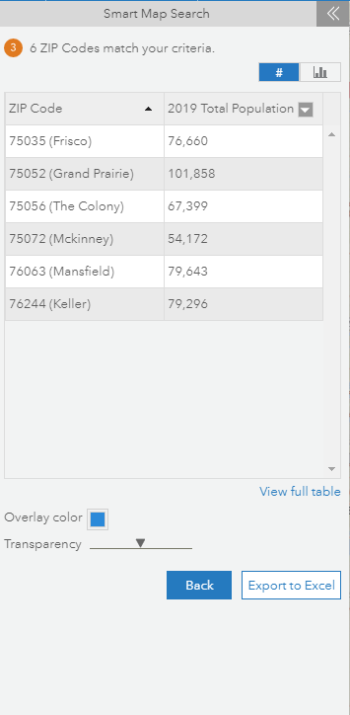

**#Screenshot of map with best locations to open a fast-food Asian restaurant**

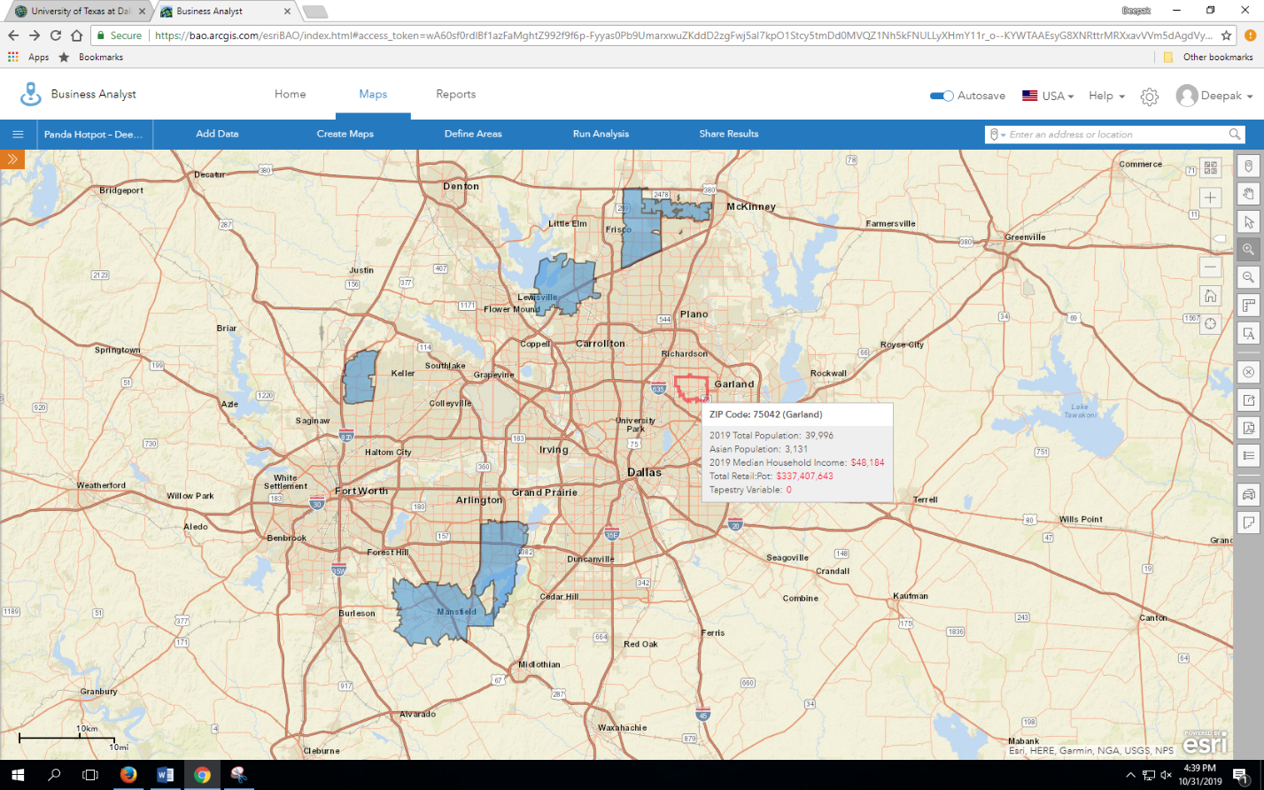

**#Updated Drive time and got 3 best locations**

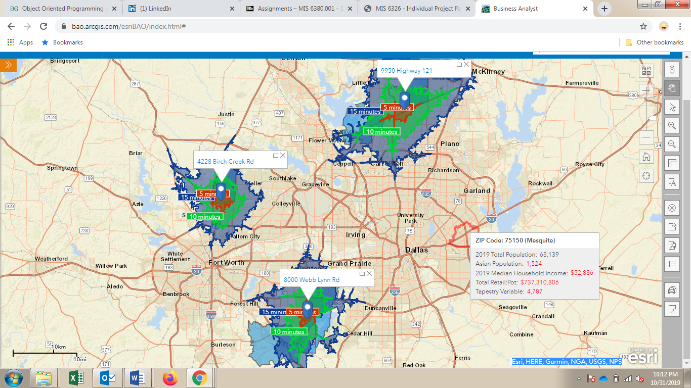

**# Geocoordinates of the three locations**

Location 1 :

X - -97.05970138 Y - 32.62599124

Location 2 :

X - -97.295103 Y - 32.896407

Location 3 :

X - -96.795069 Y - 33.101935